About the Measure
Domain | Anthropometrics
Measure | Sitting Height
Definition | Sitting Height is a segment length measure of the vertical distance from the crest or top of the head to the base of a seating surface.

About the Protocol
Description of Protocol | Sitting Height is measured with the individual seated on a table or sturdy surface with his/her back and buttocks positioned against a stadiometer post. The technician verifies that the posture is erect and that the subject’s head is positioned in a Frankfort plane before recording the measurement.
Protocol text | There are several overarching, critical issues for high-quality data collection of anthropometric measures which optimize the data in gene-environment etiologic research. These issues include: 1) the need for training (and re-training) of study staff in anthropometric data collection; 2) duplicate collection of measurements, especially under field conditions; 3) use of more than one person for proper collection of measurements where required; 4) accurate recording of the protocols and the measurement units of data collection; and 5) use of required and properly calibrated equipment.  For measuring sitting height, the examiner moves the specially made measurement box onto the floor board of the stadiometer. The participant then sits on the box with his or her back and buttocks to the backboard of the stadiometer. The participant sits as erect as possible with the head in the Frankfort Horizontal Plane position (see Figure 1). The knees are directed straight ahead with the arms and hands resting at the sides (see Figure 2). Ask the participant to sit tall and take a deep breath, and then lower the horizontal bar of the stadiometer down to the top of the head. The participant’s head is maintained in the Frankfort Horizontal Plane position throughout, and sufficient pressure is applied to the bar to compress the hair. Measurements will be recorded by the recorder to the nearest 0.1 cm.  Figure 1. Frankfort Horizontal Plane  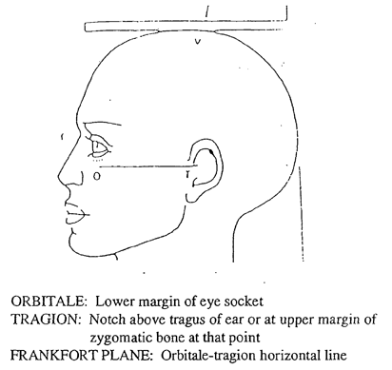  Figure 2. Participant position for Sitting Height  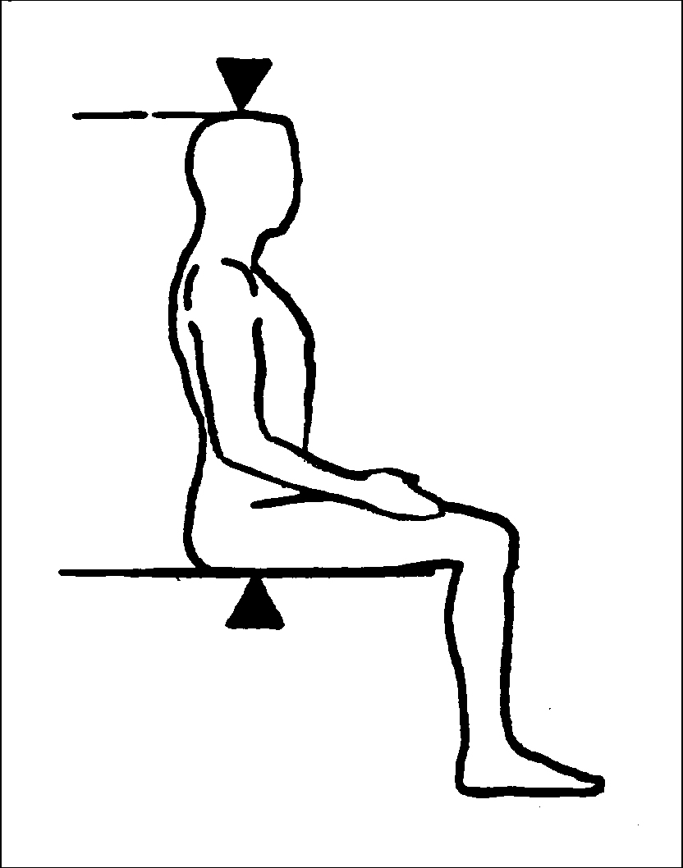
Participant | Participants 2 years of age and older
Source | National Health And Nutrition Examination Survey III, Body Measurements (Anthropometry)  http://www.cdc.gov/nchs/data/nhanes/nhanes3/cdrom/nchs/manuals/anthro.pdf
Language of Source | English
Personnel and Training Required | Health professional trained to perform anthropometric measurements
Equipment Needs | Stadiometer and sturdy bench or table
Protocol Type | Physical Measurement
General References | None
Process and Review | The Expert Review Panel #1 reviewed the measures in the Anthropometrics, Diabetes, Physical Activity and Physical Fitness, and Nutrition and Dietary Supplements domains.  Guidance from the ERP includes:  - No significant changes to measure

