About the Measure
Domain | Skin, Bone, Muscle and Joint
Measure | Rheumatoid Arthritis
Definition | This is a radiographic scoring protocol for rheumatoid arthritis.

About the Protocol
Description of Protocol | The Larsen Grading Scale© is used to determine the extent of radiographic changes due to rheumatoid arthritis. The scale scores the amount of spacing between joints, bony outlines, and level of joint erosion. This protocol does not include instructions for performing the radiographs.  Additionally, the citations for the 1987 and 2010 Rheumatoid Arthritis Classification Criteria are included in the General References section.
Protocol text | Larsen Grading Scale©  Once the radiograph(s) is obtained, the PhenX Skin, Bone, Muscle and Joint Working Group recommends that the Larsen Grading Scale© be performed by a radiologist.  The Larsen Grading Scale is applied to standard radiographs of the hands, wrists, and feet. There are 16 sites in both hands, 8 sites in both wrists, and 8 sites in both feet (Figure 1).  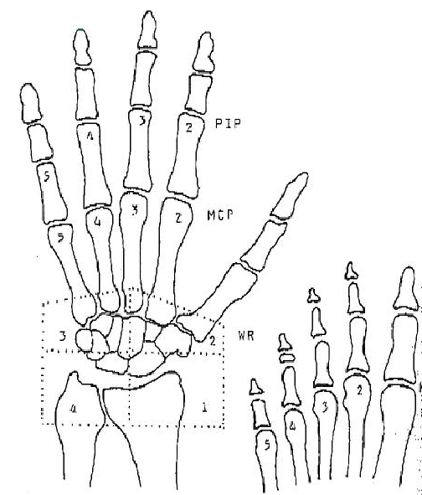  Figure 1. Sites scored by the Larsen Grading Scale  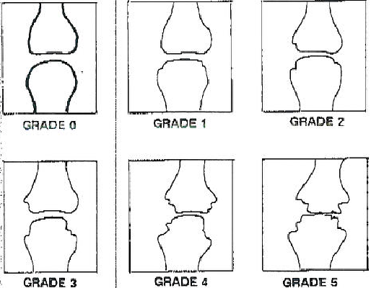  Figure 2. Larsen Grading Scale  The following grades are applied to each of the 32 joints (see Figure 2):  - Grade 0: Intact bony outlines and normal joint space.  - Grade 1: Erosion less than 1 mm in diameter or joint space narrowing.  - Grade 2: One or several small erosions (diameter more than 1 mm).  - Grade 3: Marked erosions.  - Grade 4: Severe erosions: There is usually no joint space left; the original bony outlines are partly preserved.  - Grade 5: Mutilating changes: The original bony outlines have been destroyed.  Scoring  Mean scores can be calculated separately for the hands, wrists, and feet. Alternatively, the scores of all 32 areas can be averaged together.
Participant | Adults, ages 18 and older
Source | Larsen, A. (1995). How to apply Larsen score in evaluating radiographs of rheumatoid arthritis in longterm studies? The Journal of Rheumatology, 22, 1974–1975.
Language of Source | English
Personnel and Training Required | Radiographs (x-rays) must be interpreted (“read”) by a trained radiologist.
Equipment Needs | The radiologist will need standard equipment for viewing radiographs (e.g., illumination box).
Protocol Type | Noninvasive radiologic assessment
General References | Aletaha, D., Neogi, T., Silman, A. J., Funovits, J., Felson, D. T., Bingham, C. O. 3rd, Birnbaum, N. S., Burmester, G. R., Bykerk, V. P., Cohen, M. D., Combe, B., Costenbader, K. H., Dougados, M., Emery, P., Ferraccioli, G., Hazes, J. M., Hobbs, K., Huizinga, T. W., Kavanaugh, A., Kay, J., Kvien, T. K., Laing, T., Mease, P., Ménard, H. A., Moreland, L. W., Naden, R. L., Pincus, T., Smolen, J. S., Stanislawska-Biernat, E., Symmons, D., Tak, P. P., Upchurch, K. S., Vencovský, J., Wolfe, F., & Hawker, G. (2010). 2010 Rheumatoid arthritis classification criteria: An American College of Rheumatology/European League Against Rheumatism collaborative initiative. Arthritis and Rheumatism,62, 2569–2581.  Arnett, F. C., Edworthy, S. M., Bloch, D. A., McShane, D. J., Fries, J. F., Cooper, N. S., Healey, L. A., Kaplan, S. R., Liang, M. H., Luthra, H. S., Medsger, Jr., T. A., Mitchell, D. M., Neustadt, D. H., Pinals, R. S., Schaller, J. G., Sharp, J. T., Wilder, R. L., & Hunder, G. G. (1998). The American Rheumatism Association 1987 revised criteria for the classification of rheumatoid arthritis. Arthritis and Rheumatism, 31, 315–324.

