About the Measure
Domain | Bone and Joint
Measure | Fibromyalgia - Diagnostic Criteria
Definition | A physical assessment of widespread pain and somatic symptoms of fibromyalgia.

About the Protocol
Description of Protocol | Two-part clinical examination including assessment of widespread pain and somatic symptoms related to fibromyalgia. First, an individual identifies in which, if any, of the listed 19 areas of the body they felt pain over the past week. Then, using a scale of 0 to 3, indicate the patient’s level of symptom severity (SS) over the past week.
Protocol | Part 1. Widespread Pain Index (WPI)  How to Calculate the patient’s widespread pain index (WPI).  1. Using the list of 19 body areas, identify the areas where the patient felt pain over the past week. As a visual aid, front/back body  diagrams are included.  — Each area identified on the list counts as 1.  2. Total the number of body areas (the WPI score can range from 0 to 19)  Write the patient’s WPI score here: ___________________________  Identify the areas where the patient felt pain over the past week.  [ ] Shoulder girdle, left  [ ] Shoulder girdle, right  [ ] Upper arm, left  [ ] Upper arm, right  [ ] Lower arm, left  [ ] Lower arm, right  [ ] Hip (buttock), left  [ ] Hip (buttock), right  [ ] Upper leg, left  [ ] Upper leg, right  [ ] Lower leg, left  [ ] Lower leg, right  [ ] Jaw, left  [ ] Jaw, right  [ ] Abdomen  [ ] Neck  [ ] Upper back  [ ] Lower back  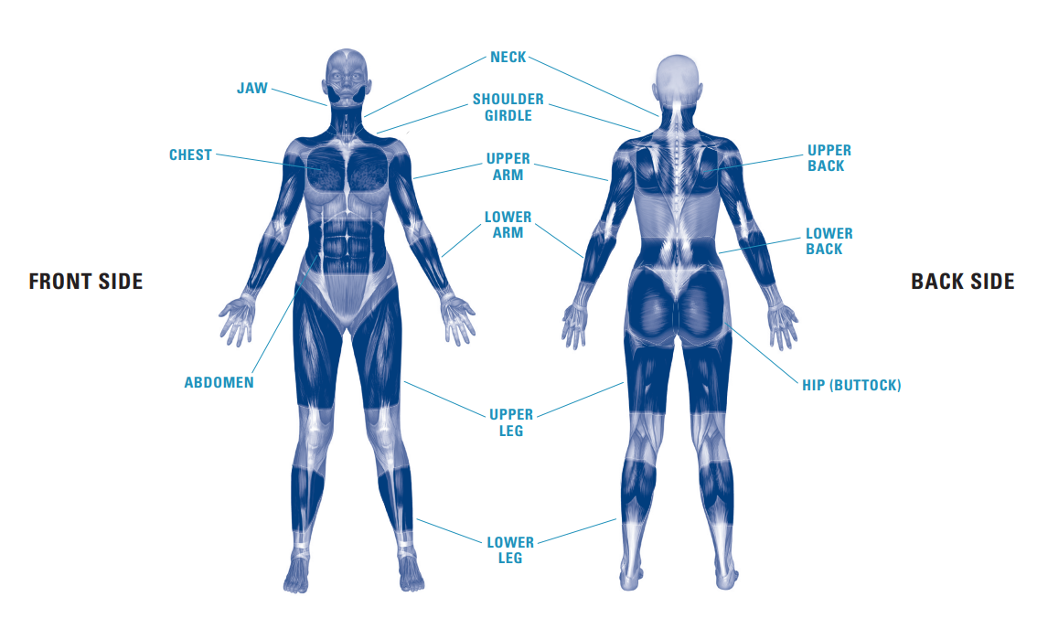  PART 2a: Symptom Severity Scale (Levels of Severity)  How to measure the patient’s level of symptom severity.  1. Using a scale of 0 to 3, indicate the patient’s level of symptom severity over the past week in each of the 3 symptom categories.  Choose only 1 level of severity for each category.  — The score is the sum of the numbers that correspond to the severity levels identified in all 3 categories.  2. Total the scale numbers for all the 3 categories and write the number here: _______________________  Fatigue  [ ] 0 = No problem  [ ] 1 = Slight or mild problems; generally mild or intermittent  [ ] 2 = Moderate; considerable problems; often present and/or at a moderate level  [ ] 3 = Severe; pervasive, continuous, life-disturbing problems  Waking unrefreshed  [ ] 0 = No problem  [ ] 1 = Slight or mild problems; generally mild or intermittent  [ ] 2 = Moderate; considerable problems; often present and/or at a moderate level  [ ] 3 = Severe; pervasive, continuous, life-disturbing problems  Cognitive  [ ] 0 = No problem  [ ] 1 = Slight or mild problems; generally mild or intermittent  [ ] 2 = Moderate; considerable problems; often present and/or at a moderate level  [ ] 3 = Severe; pervasive, continuous, life-disturbing problems  PART 3A, 3B, 3C: Fibromyalgia Survey criteria (from the Patient Self-report Survey for the Assessment of Fibromyalgia)  — For each ‘Yes’, score one point.  During the past 6 months have you had any of the following symptoms?  - Pain or cramps in lower abdomen [ ] No [ ] Yes  - Depression [ ] No [ ] Yes  - Headache [ ] No [ ] Yes  What the patient’s score means:  The patient’s WPI score (Part 1): ______________________  The patient’s SS score (Parts 2a and 3A, 3B, 3C):________________  A patient meets the diagnostic criteria for fibromyalgia if the following  3 conditions are met:  1a. The WPI score (Part 1) is greater than or equal to 7 and the SS score (Parts 2a and 3A, 3B, 3C) is greater than or equal to 5.  OR  1b. The WPI score (Part 1) is from 3 to 6 and the SS score (Parts 2a and 3A, 3B, 3C) is greater than or equal to 9.  2. Symptoms have been present at a similar level for at least 3 months.  3. The patient does not have a disorder that would otherwise explain the pain.
Participant | Fibromyalgia patients (mean ± SD age 54.6 ± 12.9) and age matched controls (52.3 ± 12.2 years).
Source | Wolfe, F., Clauw, D. J., Fitzcharles, M.-A., Goldenberg, D. L., Häuser, W., Katz, R. S., … Winfield, J. B. (2011). Fibromyalgia criteria and severity scales for clinical and epidemiological studies: A modification of the ACR preliminary diagnostic criteria for fibromyalgia. Journal of Rheumatology, 38(6), 1113–1122. https://doi.org/10.3899/jrheum.100594
Language of Source | English
Personnel and Training Required | Assessment conducted by a medical doctor or a research staff member that is trained to assess the pain sensitivity points.
Equipment Needs | None
Protocol Type | Clinical Examination
General References | Evans, V., Duarte, F. C. K., Linde, L. D., & Kumbhare, D. (2021). Differences and similarities among questionnaires to assess pain status in chronic widespread pain population: A quantitative analysis. British Journal of Pain, 15(4), 441–449. https://doi.org/10.1177/2049463720979340  Korucu, Z. T., Onurlu, İ., Korucu, A., & Günendi, Z. (2021). The effect of supervised dynamic exercise program on somatosensory temporal discrimination in patients with fibromyalgia syndrome. Archives of Rheumatology, 36(3), 409–418. https://doi.org/10.46497/archrheumatol.2021.8412  Qureshi, A. G., Jha, S. K., Iskander, J., Avanthika, C., Jhaveri, S., Patel, V. H., Rasagna Potini, B., & Talha Azam, A. (2021). Diagnostic challenges and management of fibromyalgia. Cureus, 13(10), e18692. https://doi.org/10.7759/cureus.18692
Process and Review | Not applicable.

