PROTOCOL 741402
Instructions | Image
SHOW GENERIC IMAGE OF E-PRODUCTS | 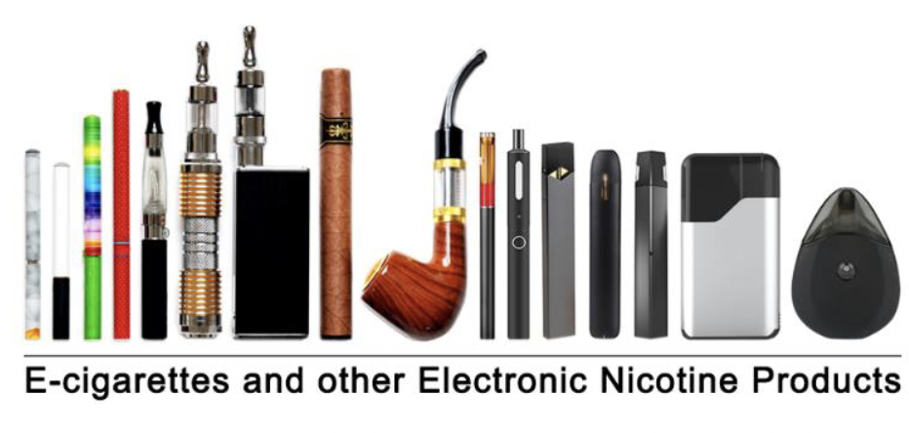
SHOW GENERIC IMAGE OF TRADITIONAL CIGARS | 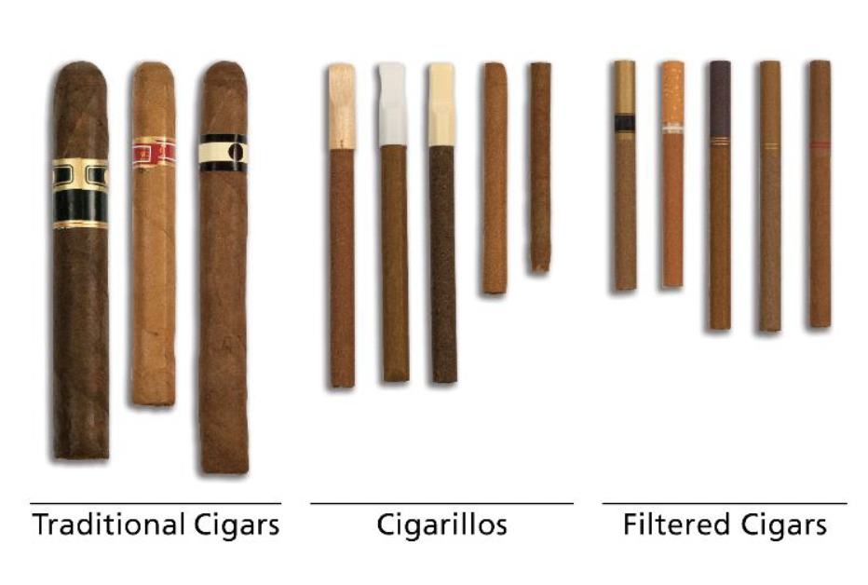
SHOW GENERIC IMAGE OF CIGARILLOS AND FILTERED CIGARS
SHOW GENERIC IMAGE OF TRADITIONAL CIGARS, CIGARILLOS, AND FILTERED CIGARS
SHOW GENERIC IMAGE OF CIGARILLOS WITH TIPS, FILTERED CIGARS, AND CIGARILLOS WITHOUT TIPS | 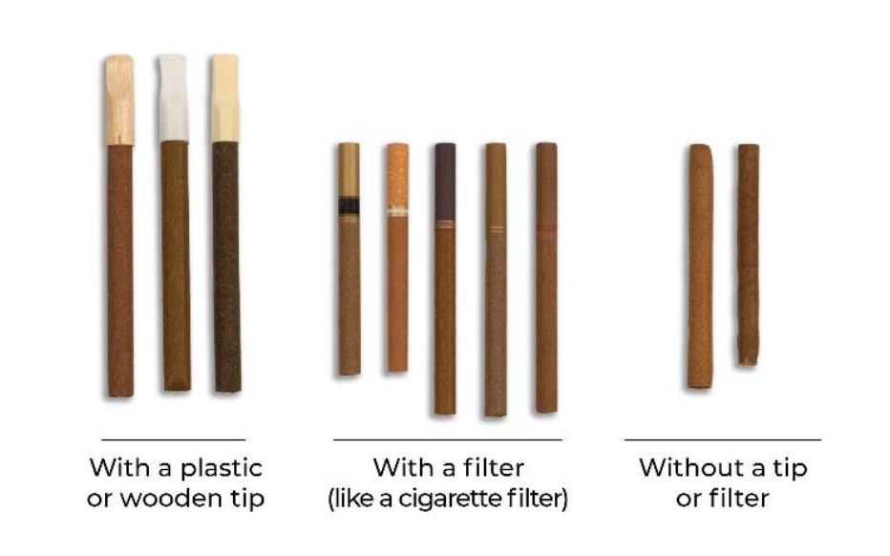
SHOW GENERIC IMAGE OF TRADITIONAL CIGARS | 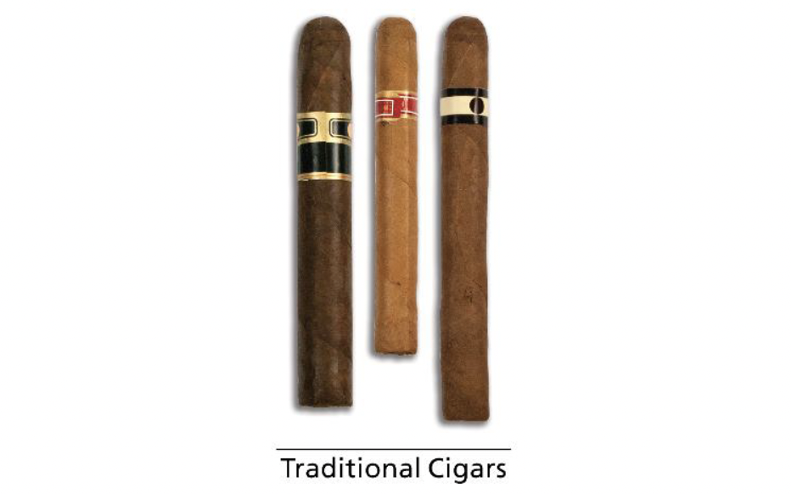
SHOW GENERIC IMAGE OF CIGARILLOS WITH TIPS | 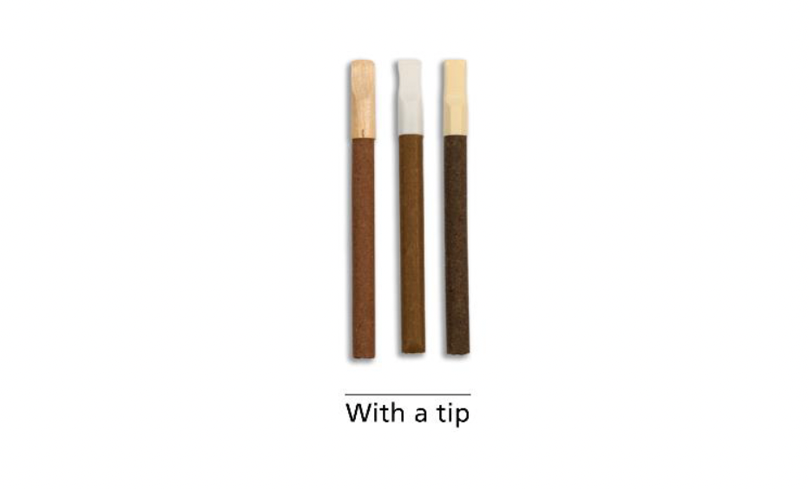
SHOW GENERIC IMAGE OF FILTERED CIGARS | 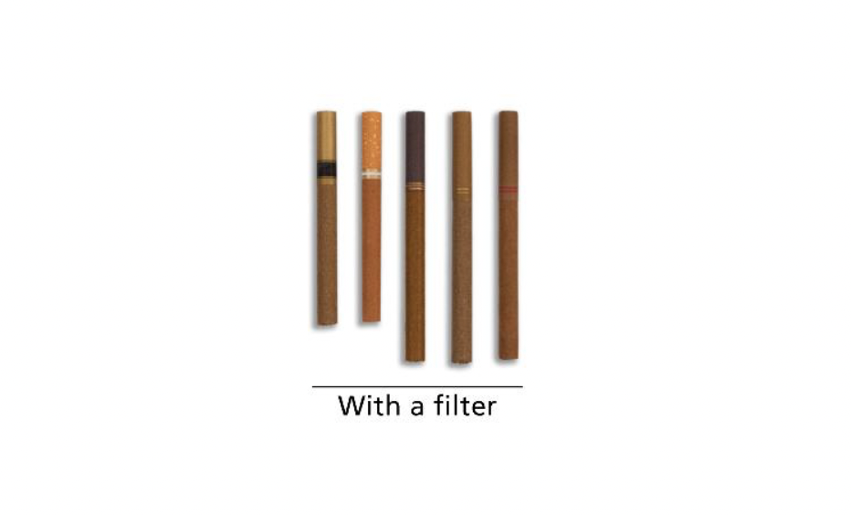
SHOW GENERIC IMAGE OF CIGARILLOS WITHOUT TIPS | 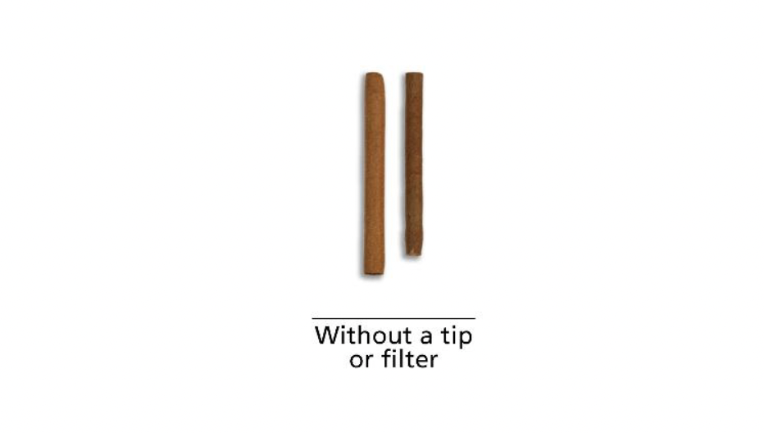
SHOW GENERIC IMAGE OF 3 CIGAR GROUPS | 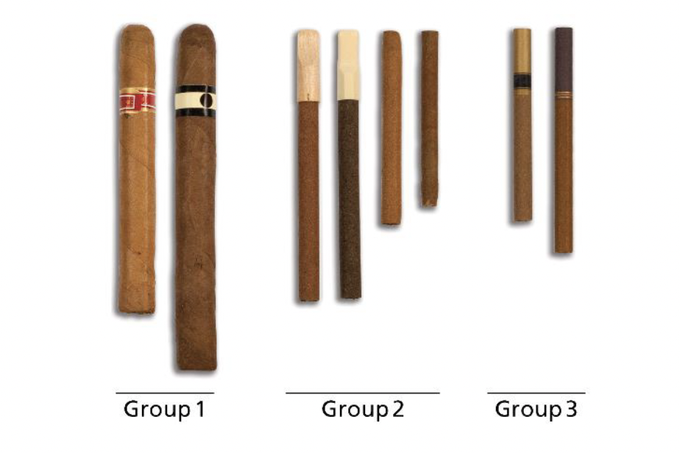
SHOW GENERIC IMAGE OF CIGARTYPE  If 31=1, show traditional cigars | 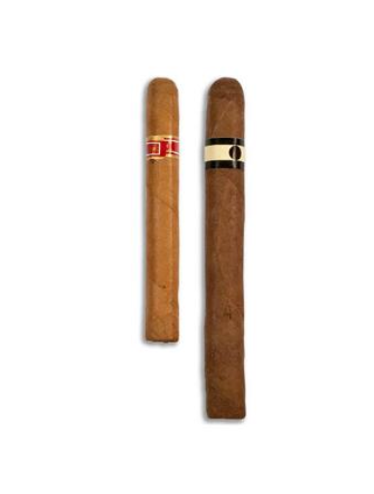
SHOW GENERIC IMAGE OF CIGARTYPE  If 31=2, show cigarillos | 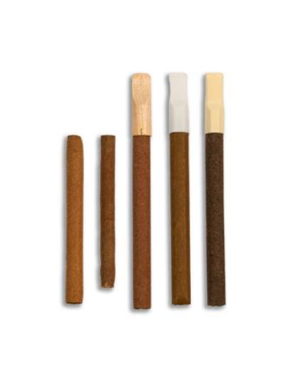
SHOW GENERIC IMAGE OF CIGARTYPE  If 31=3, show filtered cigars | 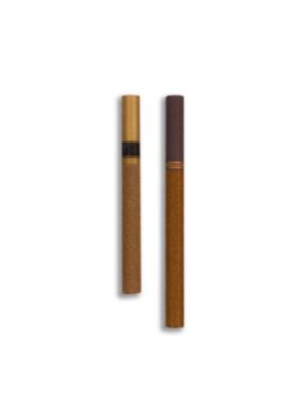
SHOW GENERIC IMAGE OF PIPE | 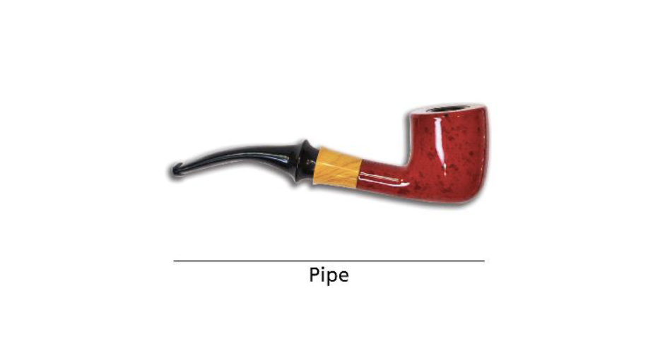
SHOW GENERIC IMAGE OF HOOKAH | 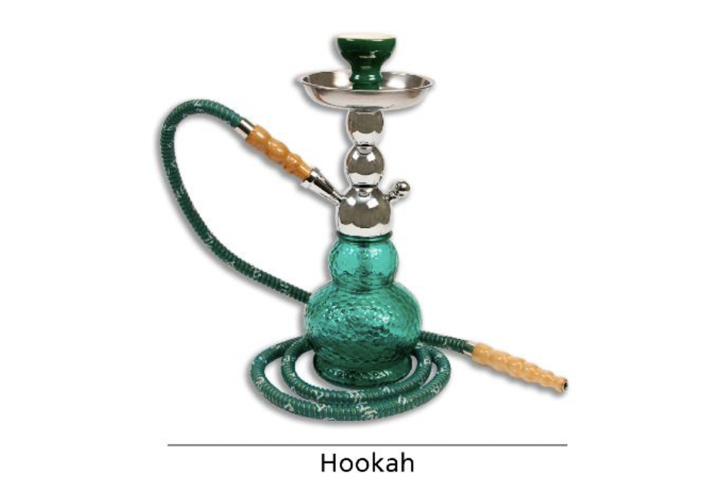
SHOW GENERIC IMAGE OF SMOKELESS PRODUCTS, EXCLUDING SNUS | 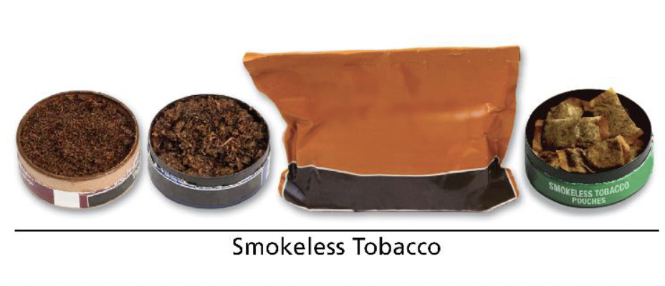
SHOW GENERIC IMAGES OF SMOKELESS TOBACCO
SHOW GENERIC IMAGE OF SNUS – BOTH LOOSE AND POUCHES | 